**UNIT-III: Optoelectronics**

Radiative and non-radiative recombination mechanisms in semiconductors, LED and semiconductor lasers: Device structure, Materials, Characteristics and figures of merit, Semiconductor photodetectors: Solar cell, PIN and Avalanche and their structure, Materials, working principle and Characteristics.

**UNIT-3**

**OPTOELECTRONICS**

**Radiative and non radiative recombination mechanism in semiconductors**

Like other solids, semiconductor materials have an [electronic band structure](https://en.wikipedia.org/wiki/Electronic_band_structure) determined by the crystal properties of the material. Energy distribution among electrons is described by the [Fermi level](https://en.wikipedia.org/wiki/Fermi_level) and the [temperature](https://en.wikipedia.org/wiki/Temperature) of the electrons. At [absolute zero](https://en.wikipedia.org/wiki/Absolute_zero) temperature, all of the electrons have energy below the Fermi level; but at non-zero temperatures the energy levels are filled following a Boltzmann distribution.

In undoped semiconductors the Fermi level lies in the middle of a *forbidden band* or [band gap](https://en.wikipedia.org/wiki/Band_gap) between two *allowed bands* called the [*valence band*](https://en.wikipedia.org/wiki/Valence_band) and the [*conduction band*](https://en.wikipedia.org/wiki/Conduction_band). The valence band, immediately below the forbidden band, is normally very nearly completely occupied. The conduction band, above the Fermi level, is normally nearly completely empty. Because the valence band is so nearly full, its electrons are not mobile, and cannot flow as electric current.

However, if an electron in the valence band acquires enough energy to reach the conduction band, it can flow freely among the nearly empty conduction band energy states. Furthermore, it will also leave behind a hole that can flow as current exactly like a physical charged particle.

**Carrier generation** describes processes by which electrons gain energy and move from the valence band to the conduction band, producing two mobile carriers; while **recombination** describes processes by which a conduction band electron loses energy and re-occupies the energy state of an electron hole in the valence band.

.

Recombination and generation are always happening in semiconductors, both optically and thermally, a material at [thermal equilibrium](https://en.wikipedia.org/wiki/Thermal_equilibrium) will have generation and recombination rates that are balanced so that the net [charge carrier](https://en.wikipedia.org/wiki/Charge_carrier) density remains constant..

{\displaystyle \eta ={\frac {1/\tau \_{r}}{1/\tau \_{r}+1/\tau \_{nr}}}={\frac {radiative\ recombination}{total\ recombination}}\leq 1.}

## Radiative Recombination

### Radiative recombination

*Band-to-band recombination* is the name for the process of electrons jumping down from the conduction band to the valence band in a radioactive manner. During band-to-band recombination, a form of [spontaneous emission](https://en.wikipedia.org/wiki/Spontaneous_emission), the energy absorbed by a material is released in the form of [photons](https://en.wikipedia.org/wiki/Photon). Generally these photons contain the same or [less](https://en.wikipedia.org/wiki/Stokes_shift) energy than those initially absorbed. This effect is how [LEDs](https://en.wikipedia.org/wiki/Light-emitting_diode) create light. Because the photon carries relatively little [momentum](https://en.wikipedia.org/wiki/Momentum), radioactive recombination is significant only in [direct band gap](https://en.wikipedia.org/wiki/Direct_bandgap) materials. This process is also known as *bimolecular recombination*[[3]](https://en.wikipedia.org/wiki/Carrier_generation_and_recombination" \l "cite_note-3)*.*

## Non-radiative recombination

Non-radiative recombination is a process in [phosphors](https://en.wikipedia.org/wiki/Phosphor) and [semiconductors](https://en.wikipedia.org/wiki/Semiconductor), whereby [charge carriers](https://en.wikipedia.org/wiki/Charge_carrier) recombine with releasing [phonon](https://en.wikipedia.org/wiki/Phonon) instead of [photons](https://en.wikipedia.org/wiki/Photon). Non-radiative recombination in optoelectronics and phosphors is an unwanted process, lowering the light generation efficiency and increasing heat losses.

Non-radiative life time is the average time before an [electron](https://en.wikipedia.org/wiki/Electron) in the [conduction band](https://en.wikipedia.org/wiki/Conduction_band) of a [semiconductor](https://en.wikipedia.org/wiki/Semiconductor) recombines with a [hole](https://en.wikipedia.org/wiki/Electron_hole). It is an important parameter in [optoelectronics](https://en.wikipedia.org/wiki/Optoelectronics) where [radiative recombination](https://en.wikipedia.org/wiki/Radiative_recombination" \o "Radiative recombination) is required to produce a [photon](https://en.wikipedia.org/wiki/Photon); if the non-radiative life time is shorter than the radiative, a carrier is more likely to recombine non-radiatively. This results in low internal [quantum efficiency](https://en.wikipedia.org/wiki/Quantum_efficiency).

**Light Emitting Diode (LED):**

A light Emitting diode is specially made forward biased P-N junction diode which emit visible light when energized.

***Principle:*** Recombination of an electron-hole pair emits the light energy.

**Construction:** At first an N-type layer is grown on a substrate and then a p-type layer is deposited on it by the process of diffusion. Metal contacts (Anode) are made at the outer edge of the p-layer so that more upper surface is left free for light to escape. For making cathode, a metal film is coated at the bottom of the substrate. This film also reflects as much light as possible to the surface of the device.

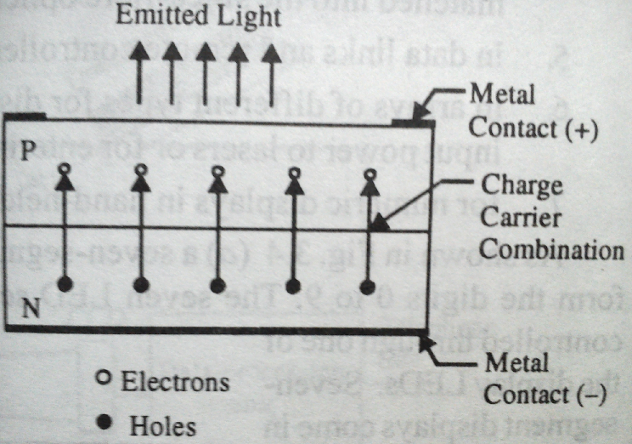 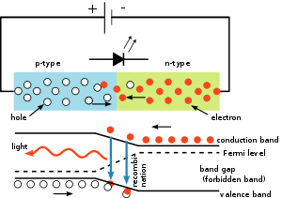

**Working:**

When a junction diode is forward biased electrons from n-side and holes from p-side move towards the depletion region and they recombine. During this process, energy is released in the form of light and heat .Because electrons make transition from conduction band (higher energy level) to valance band (lower energy level).

If Eg is the semiconductor energy band gap, then **Eg = hν = h.c/λ** is emitted in the form of radiation.

The corresponding emission wavelength is given by **λ = hc/Eg**

For Ge and Si junctions greater percentage of energy is emitted in the form of heat, but for some materials like GaAs, GaP and GaAsP, greater percentage of energy is emitted in the form of light during recombination process.

**Volt-Ampere Characteristics:**

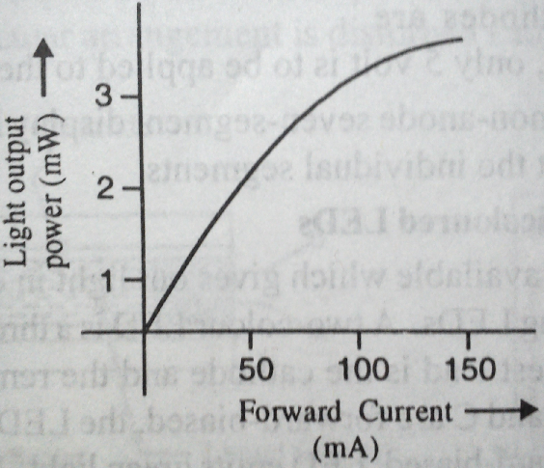

The forward voltage across an LED is greater than the for a silicon p-n junction diode. It is between 1.2 V and 3.2 Volts depending on the device. Reverse breakdown voltage is of the order of 3V to 10V. The LED emits light

in response to a sufficient forward current. The amount of power output translated into light is directly proportional to the forward current as shown

in fig. It is evident from this fig. that greater the forward current, greater the light output.

Life time of LED is about – 105 hours. Response time of LED is – 10-9 s.

**Material:** GaAs, GaAsP, GaP, SiC, GaInN

**Colour:** Infrared, Red , Green, Blue, White

**Applications:**

1. LEDs can be used for numeric displays such as seven segment display in hand-held (or) pocket calculators. By activating suitable number of combination of LED’s in this unit, any digit 0 to 9 can be displayed by it.

2. Used in burglar-alarm systems.

3. Used for solid state video displays.

4. Used in optical fiber communication system.

5. Used as light source in traffic signals.

1. **\*\*\* Semiconductor Laser diode:-**

The first semiconductor lasers were made by Hall and Nathan in 1962 using Gallium Arsenide(GaAs). The semiconductor laser is also called as diode laser. It has same principle like light emitting diode (LED).

On the basis of recombination, semiconductor lasers classified into two types. They are

(i) Home junction semiconductor laser. (Ex:-GaAs)

(ii) Hetero junction semiconductor laser. (Ex:-GaAlAs)

**(i).\*\*\* Home junction semiconductor laser(or) GaAs laser:-**

If junction is formed between p-type and n-type semiconductors of same type material, it is called as home junction semiconductor laser.

**Characteristics**:-

(i) Type:-Semiconductor laser (ii)Active medium: P-N junction diode (iii) Active center:- Recombination of electrons& holes (iv)Pumping method: Direct pumping (v)Optical Resonator: junction of diodes polished (vi) Output power:1mw

(vii)Nature of output : continuous (or)pulsed (viii) Wavelength=8400 to 8800 A0.

**Principle:-** When the P-N junction is forward biased, the width of the depletion region decreases, allowing more no. of electrons from n-type to cross the junction and recombine with holes in P-type.

Thus recombination of electron hole pairs across the junction and emits the radiation (photons) as shown in fig.2&3.

**Construction:**-

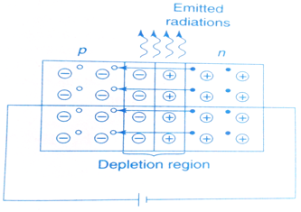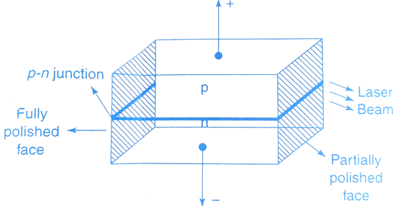

fig.1 GaAs laser fig.2 Forward biased P-N junction

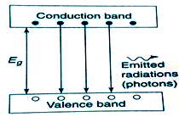

The GaAs laser was constructed by Hall. It is shown in fig.1. A rectangular block of GaAs semiconductor is converted into P and N- type by proper doping of impurities into the block.

The upper region acts as p-type and lower region acts as n-type. Between these two regions, a p-n junction is formed. To achieve population inversion p and n regions are heavily doped with the impurities. Two faces of the block, one is fully polished and the other partially polished, act as an optical resonator or cavity.

Fig.3 Energy Level Diagram

**Energy Level Diagram(ELD):-**It is shown in fig.3

**Working**:-

When the p-type is connected to the positive (+ve) terminal of a battery and n-types is connected to the negative ( –ve) terminal of a battery, and then the junction is in forward biased condition as shown in fig.2.

When the junction is forward biased, the width of the depletion region decreases, allowing more no. ofelectrons from n-type to cross and recombine with hole in P-type. Thus, the recombination of electron-hole pairs takes place across the junction and emits the laser radiation or photons.

The energy of emitted laser radiation is given by, E = hν(or)

Energy gap Eg = hν = $\frac{hc}{λ}$

Wavelength of laser is, λ = $\frac{hc}{E_{g}}$

Where, h is Planck’s constant and c is Velocity of light.

\* For GaAs semiconductor, **Eg**= 1.4ev, therefore the wavelength is, λ = 8874 A0

We get light in the infrared region.

**Advantages**:- (i) Its efficiency is high (ii) Output is tunable (iii) the laser output can be modulated within the semiconductor itself (iv) laser output is pulsed or continuous.

**ii. HETERO-JUNCTION SEMI CONDUCTOR LASER:-**

If junction is formed between p-type&n-type semiconductors of different materials, it is called as hetero junction semi conductor laser.

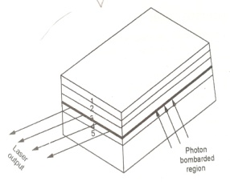 The working principle is same for the both homo&hetero junction semiconductor lasers.

Ex:-GaAlAs.

It is shown in fig. itconsists of various layers like1,2,3,4&5.The laser emission take place between 2&4 layers.

**Photo Diode: (Detector)**

A photo diode is a reverse biased P-N junction diode whose reverse current increases with the increase in intensity of light incident at the junction. It is designed to respond to photon absorption. It converts light energy into electrical energy. The function of the photo diode is opposite of an LED.

**Principle:** When light is incident on the depletion region of the reverse biased p-n junction, the concentration of minority carriers (electrons in P type and holes in the n type) increases to a great extent, but the change in the majority carriers is too low. Consequently reverse current increases. As the intensity of light on the junction increases, the reverse current also increases.

A reverse biased P-N junction diode has a reverse saturation current which is mainly due to the flow of minority carriers.

**Construction:**

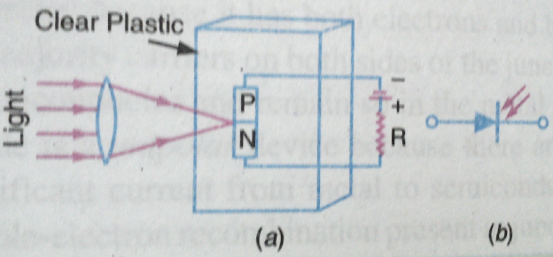 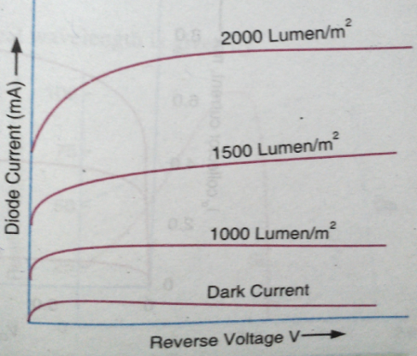

A photo diode consists of a P-N junction embedded in a clear plastic capsule. Light is allowed to fall upon one surface across the junction. All the sides of the plastic capsule, excepting the illuminated one, are either painted black or enclosed in a metallic case.

**Working:**

When photo diode is kept under dark condition and a sufficient reverse voltage is applied, then an almost constant current, independent of magnitude of reverse bias, is obtained. This current corresponds to the reverse saturation current due to thermally generated minority carriers. It is called dark current. It is proportional to the concentrations of minority carriers and is denoted by Id, majority charge carriers are not allowed to cross the junction by the potential hill under this reverse bias condition.

When light falls on the diode surface, additional electron – hole pairs are formed. But since the concentration of majority carriers is much greater as compared to that of minority carriers, the percentage increase of majority carriers is much smaller than the percentage increase of minority carriers. Hence, we can neglect the increase in majority carrier density and can consider the radiation entirely as a minority carrier injector. These injected minority carriers diffuse to the junction, cross it and contribute to the additional current.

Thus , under large reverse bias condition, the total reverse current is given by, I = Is+Id

Where Is is the short circuit current and is proportional to light intensity.

With any bias V, the dark current is, Id = Io(1 - e-eV/ηkT)

Hence, the volt-ampere characteristic equation of photo diode is given by, I = Is+Io(1 - e-eV/ηkT)

Where, η =1 for Ge and η =2 for Si.

**Volt-Ampere Characteristics:**

The Volt-Ampere Characteristic curve of a photo diode is shown in fig.c. From the curve

1. The current increases with increase in the level illumination for a given reverse voltage.
2. Only for the dark current at zero voltage the current is zero.

When an electron – hole pair is generated by photon absorption with in depletion region, the internal field causes the electron and hole to separate, this charge separation can be detected in two ways.

1. **Photo voltaic mode:** If the device is left an open circuit, an externally measurable potential appears between p and n regions. This is known as the photovoltaic mode of operation.
2. **Photo conductive mode:** If the device is short circuited an external current flows between the p and n regions. This is known as photoconductive mode of operation. Under photoconductive mode it is operated under reverse bias conditions.

We have two different Photo diodes. They are

1. P-i-n Photo diode 2. Avalanche Photo diode

.

1. **p-i-n Photo diode:**

**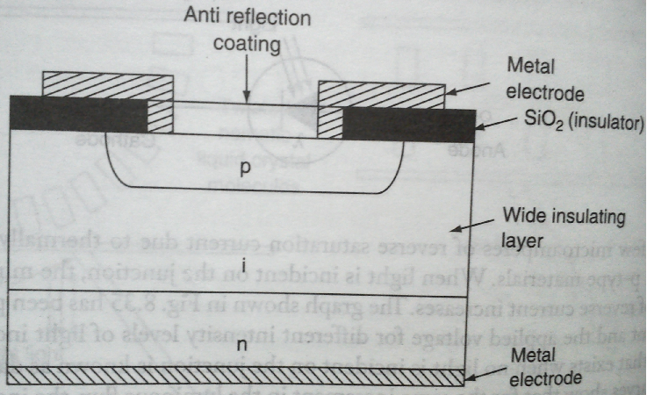**

The structure of p-i-n diode is shown in fig. It consists of a p-n junction separated by a wide insulating layer (i). On biasing a large electric field exists across this layer. This field sweeps the excess holes and excess electrons across the insulating layer ‘i ‘by drift. These excess carriers contribute to photo current. For biasing the diode, two metal electrodes

are present, one at the bottom and other at the top of the layers. This is

used in switching and logic circuits, and to detect laser pulses.

1. **Avalanche Photo diode:**

In the avalanche photodiode internal amplification of the photocurrent is achieved. In this device, the basic p-n junction diode is operated under very high reverse bias voltage resulting in a current gain of nearly 1000.This is known as avalanche breakdown. Carriers in the depletion region having sufficient energy to excite other carriers through collisions. Thus, electron-hole pairs are generated.

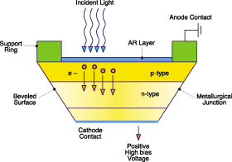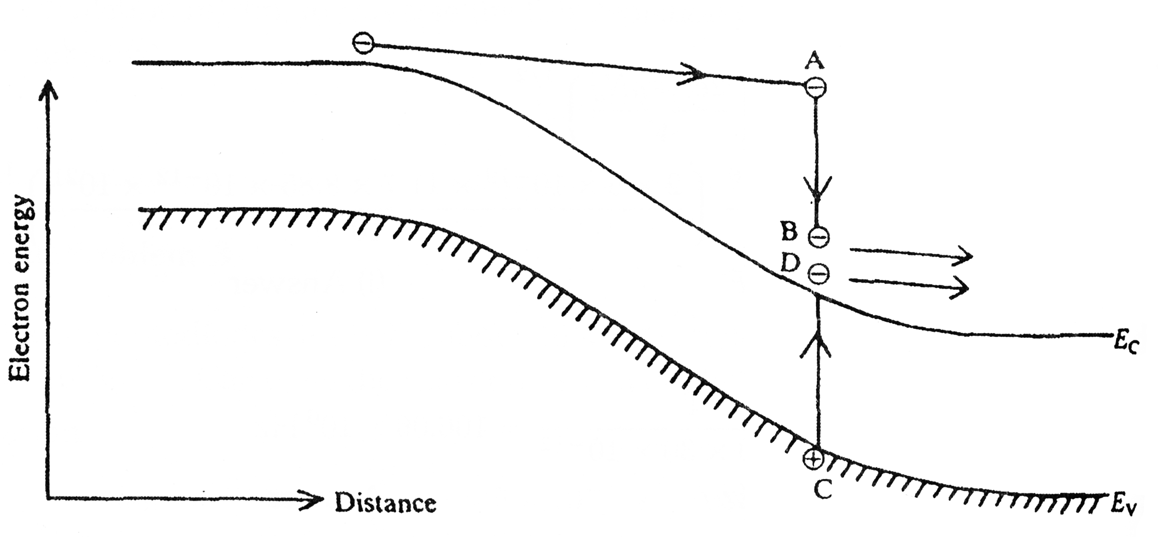

1. **Figure : Illustration of the principle of operation of an avalanche photodiode**

An electron having reached the point A, have sufficient energy to exite an electron from valance band to conduction band(C →D). In this process though the exciting electron loses energy (A →B) still it is inside the conduction band and hence there is no loss of charge carriers. These newly generated charge carriers may generate further electron hole pairs by the same process and thus current gains in excess of 100 are rapidly obtainable. Current gain is very sensitive to the value of the bias voltage to get uniform gain throughout the diode, a highly uniform field is provided across the diode.

Avalanche photodiodes are very popular in the field of fiber optical communication systems.

**Applications of a Photo diode:**

1.They are used in light detection, both visible and invisible. 2. Demodulation 3. Switching 4. Logic circuits 5. Character recognition

6. Optical fiber communications 7. Encoders 8. In alarm circuits. 9. Reading of film sound track 10. High speed reading of computer punched cards and tapes.

**Solar cell (or) Photo Voltaic Cell:-**

A **solar cell is basically a p-n junction diode which converts solar (or) light energy into electrical energy.**

It is also called a **photovoltaic cell.** It is a form of **photoelectric cell** , in that its electrical characteristics like current, voltage, or resistance vary when light is incident upon it. When it is exposed to light, can generate an electric current without being attached to any external voltage source. The function of the solar cell is opposite of an LED.

Common materials for solar cells include Si, GaAs, InAs and CdAs. The most common is silicon.

**Construction:**

A solar cell consists of P-N junction diode made of silicon as shown in fig.1 and its schematic symbol is shown in fig.2.

The inward arrow indicates the incoming light. The p-n junction diode is packed in a can with glass window on top so that light may fall upon p and n type materials.

**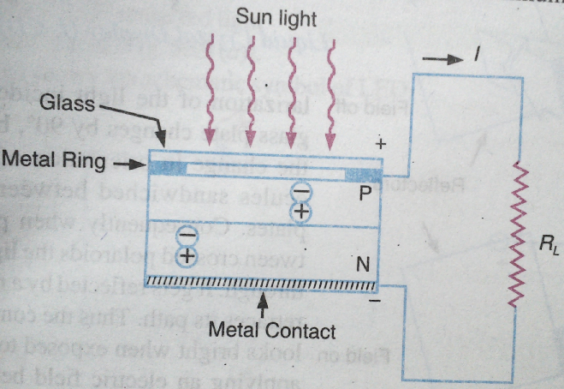 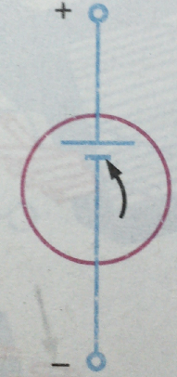**

The thickness of the p-region is kept very small so that electrons generated in this region can diffuse to the junction before recombination takes place. Thickness of N-region is also kept small to allow holes generated near the surface to diffuse to the junction before they recombine. A heavy doping of P and N regions is recommended to obtain a large photo voltage.A nickel plated ring is provided around the P-layer which acts as the positive output terminal. A metal contact at the bottom serves as the negative output terminal.

**Working:**

When light radiation falls on P-N junction diode, photons collide with valence electrons and impart them sufficient energy enabling them to leave their parent atoms. Thus electron –hole pairs are generated in both the P and N sides of the junction. These electrons and holes reach the depletion region W by diffusion (shown in fig.3) and are then separated by the strong barrier field existing there. The minority carrier electrons in the P-side slided down the barrier potential to reach the N-side and the holes in the N-side move to P-side as shown in fig.4. Their flow constitutes the minority current which is directly proportional to the illumination and also depends on the surface area being exposed to light.

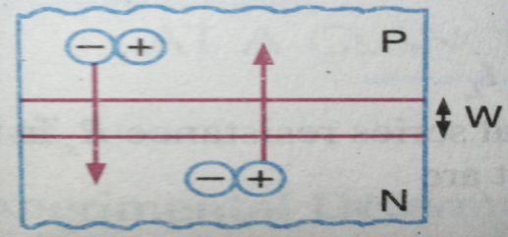 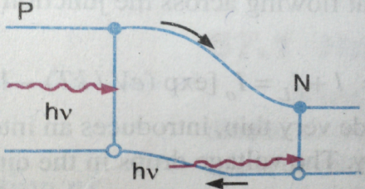 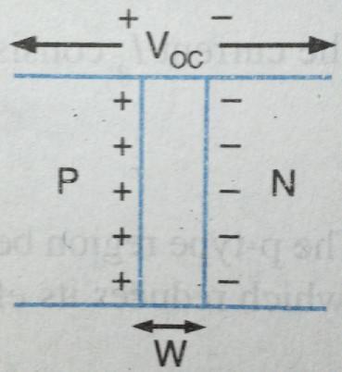

Fig.3 fig.4 fig.5

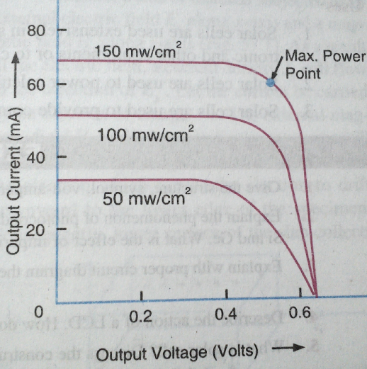The accumulation of electrons and holes on the two sides of the junction gives rise to an open circuit voltage Voc which is a function of illumination. The open circuit voltage produced for a silicon solar cell is about 0.6 volt and short circuit current is about 40 mA/cm2 in bright noon day sun light.

**V-I Characteristics:**

The V-I characteristics of a solar cell , corresponding to different levels of illumination are shown in fig. Maximum power output is obtained when the cell is operated at the knee of the curve.

**Applications of a Solar cell:**

There are three broad categories for photovoltaic applications. They are

1. *Industrial Applications:*

i. Used for telecommunication pv systems in remote and difficult to access areas like mountain tops, islands and deserts.

ii. Used in cathodic protection iii. Alarm systems iv. Defence equipment v.Remote aircraft beacons

vi. Automatic meteorological stations vii. Used in satellites and space vehicles to supply power to electronic and other equipments or to charge storage batteries.

1. *Social Applications:*

i. PV devices are used to provide commercial electricity. ii. Used to provide electrical power to remote areas.

iii. PV device is used to power refrigerator for keeping vaccines at low temperatures.

1. *Consumer Applications:*

Some consumer products such as pocket calculators, watches, torches, garden lights, portable fans for cars and houses, radios, toys, electric fences, etc ., are powered by PV solar systems.